**REQUIREMENT ENGINEERING**

**INCEPTION/ELICITATION**: To carry out the inception task a questioning session was carried out by members of Team Hoff Members. This session was directed towards students of the engineering department, specifically first years. The following are the questions that was asked to fully understand the problem and its requirements:

* Do you have the course materials needed for the semester?
* If Yes, how did you get them?
* If No, why?
* Would you like an app that could help you easily access the materials for all the various years?
* What do you think about an app that contains lecture slides, reference materials and videos?
* Will this solve the problem?

After the questioning by members of TEAM HOFF, it was identified that:

* A few engineering students could easily get the course materials they needed for the program.
* Most engineering students found it difficult to access the learning materials required for a semester.
* Others complained of the course materials using up the limited memory they had. As a result, they had to delete the course materials once they are done with the semester, this made it difficult for them to make reference to courses from previous semesters.
* Others complained that their laptops got infected by viruses, which led to loss of important information.

After thinking through the problem, we found that course library was a plausible and efficient solution. The course library will be available on a web app to allow students to easily access all materials that will facilitate the studying of the various course. Also, it would be safe from virus

**ELABORATION**

The application will be a web app. It will consist of an interface which will help the user access the materials. Course materials, reference books will be stored in a file storage system and a server receives request from the user and provides these files for the user with the help of a database. The app will also consist of a discussion forum where discussions on topics can be held.

**NEGOTIATION**

After thinking through the model we elaborated, we decided with some engineering students to keep all the components except the discussion forum. The discussion forum could be ignored as students could easily convey queries to lecturers. Also, it was not possible for most lecturers to continuously check for the queries of students.

**SPECIFICATION**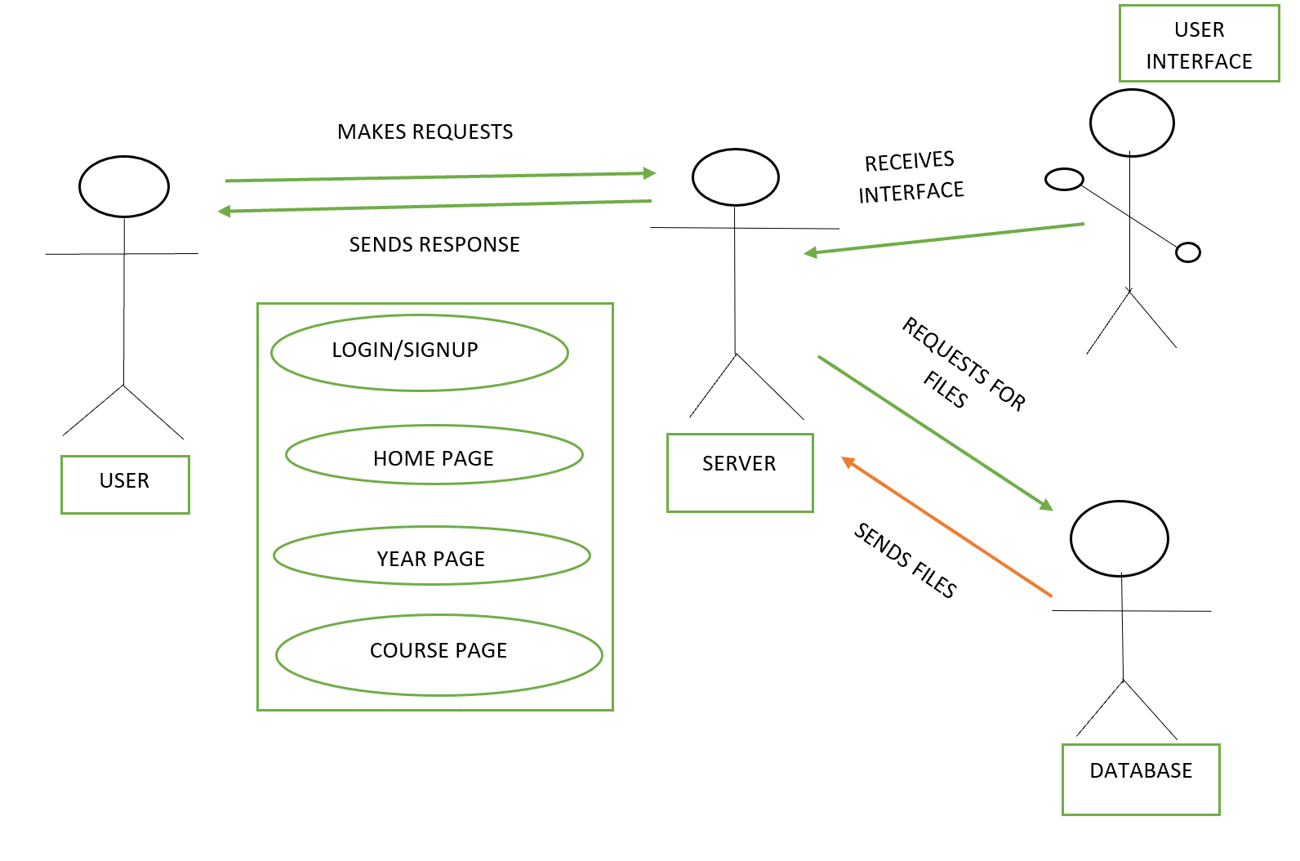

The web app will be made up of 5 general pages. The signup page, the login page, the homepage, the program page and the course page.

* The signup page: Accepts the credentials of the user (full name, username, email, password, program and year)
* The login page: Allows the client to access the web app after it has been authenticated
* The homepage: Contains some recommended books based on the program indicated, a search bar, a profile id and a list of the various engineering programs.
* The year page: Contains the year and the list of courses in the two semesters
* The program page: Contains the four levels of a program
* The course page: Contains the lecture slides, reference material and links to tutorial videos
* The homepage, program page and course page will have a common layout

**VALIDATION**

In the validation of the various pages, it was decided that adding a year field to the signup could be left out. Also, the program page was deemed as a waste of space as the four years could easily be a dropdown of the programs. A navigation bar was added to help easy navigation between the various pages.